Paige Redlin
Tasha Candela
Career Field Experience
November 30, 2016
Macomb County Treasurer’s Office
“Opportunity is as scarce as oxygen; men fairly breathe it but do not know it” -Doc Sane. This opportunity that is my internship at the Macomb County Treasurer’s Office is an unreal experience that I am thankful to have been a part of. In my Career Field Experience class, I was required to not only work three days a week in a demanding office, but also complete reflective weekly assignments that allowed me to look back upon my work week. In my opinion, Career Field Experience is a unique class because it gave me the chance to experience what the business field entails along with exposure potential relationships. For thirteen weeks, I learned every aspect of what the Macomb County Treasurer's Office entails; I broadened my knowledge on delinquent taxes, foreclosure, and even local elected officials. While reflecting on my overall learning experience in this class, I will outline the three employability skills of professionalism, adaptability, and problem-solving and how I have grown as a professional.
I believe that professionalism could be considered a vast aspect of my internship at the Macomb County Treasurer's Office. Professionalism must be utilized in an office when a seventeen year old is thrown into an office of middle aged men and women who have been completing the same tasks for multiple years. I had to use a professional and cooperative approach to tasks to conform to my surroundings. By utilizing a professional approach respect is gained by my colleagues and my mentors. Additionally, this skill was displayed when I wore appropriate office attire on a daily basis. I believe by presenting myself as a professional, I was able to create an impressive and respectable impression on my colleagues.
Adaptability would be considered one of the largest aspects of my internship as well. This is due to the shift in surroundings from MMSTC, to Lake Shore, to the treasurer’s office. It is evident, that each of the three places I spend time at on a daily basis have different surroundings and expectations. The largest adaptation from Lake Shore to work would have to be the socialization. My office is relatively quiet, therefore contrasting greatly with the obnoxiously loud hallways of Lake Shore. There is a significant amount of “adult” small talk; I have never talked about weather so often in my life until I started working here. I have developed the ability to adapt to a more professional and highly-respected setting by completing my internship at the Macomb County Treasurer’s Office.
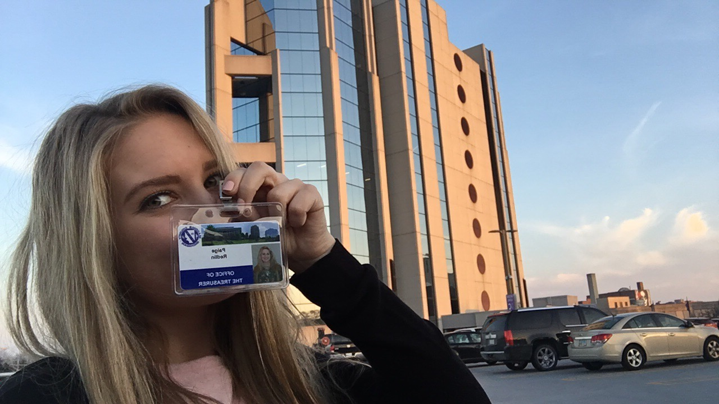
Lastly, my problem-solving skills have been significantly improved within the past thirteen weeks of my life due to my internship. I was thrown into numerous problem solving situations even within my first few weeks on the job. In an office as fast pace as mine, you must do things for yourself and be able to figure out complicated and simple problem solving tasks. For example, if I was set on an assignment that pertained to the local election I would have to contact the elections department and work hand in hand with them. I am expected to make these connections and contacts myself, rather than relying on my boss or mentor to be my aid. This accompanies the fact that you are expected to be a self-starter at an office job such as this. Problem-solving is seen in everyday life, no matter what type of tasks are being completed; Therefore, this internship has not only prepared my for future job experiences, but life experiences.
I believe my strengths of self-starting, logical reasoning, and problem solving hold true to my character. Throughout the past four years of my high school career, I have been conditioned to keep a strict schedule and constant motivation; Now, when I set myself to any ask I work independently and do not need to be nagged and reminded on what needs to be completed. Additionally, logical reasoning and problem solving have always been two significant characteristics that made up my personality. I have developed these skills over the past four years by juggling numerous responsibilities and difficulties. In contrast, I also agree fully with a few of my weaknesses on my final evaluation: organization and verbalizing instructions in a clear manner. I have been told numerous times that my sense of organization is quite different. I would call my organization method, “I know exactly where it is, but I can't tell you why it is there”. I believe that I could adopt more concise organization methods, therefore everything will be simple to navigate without explanation. In addition, I am still learning every aspect of vocabulary in the office, proving it difficult at times for myself to verbalize what I may have questions on. Time will fix this weakness because practice makes perfect.
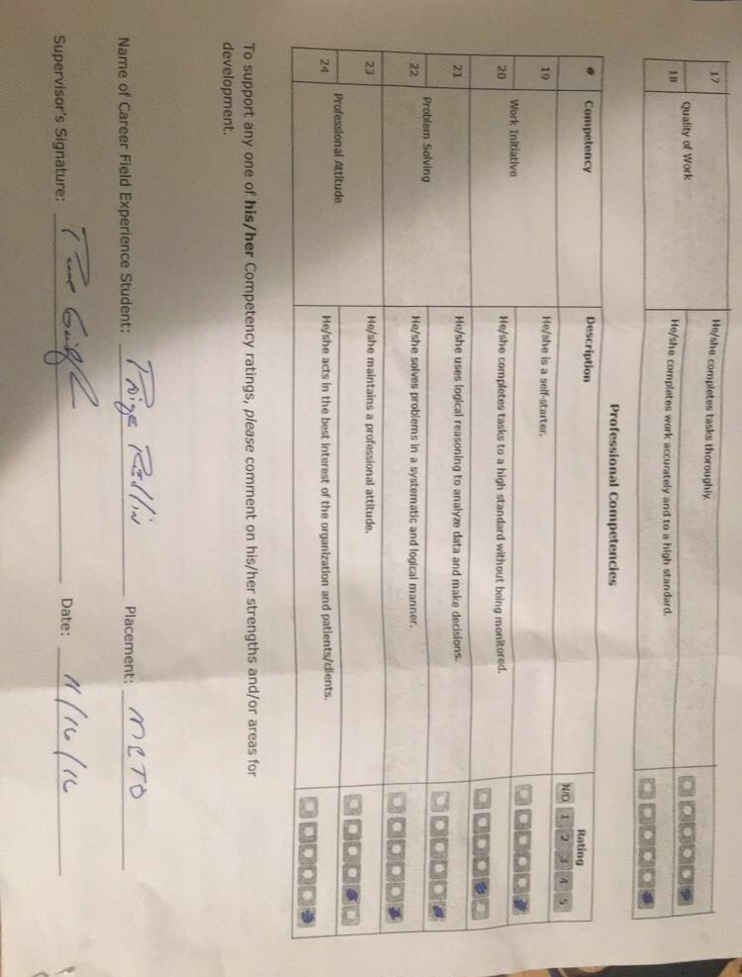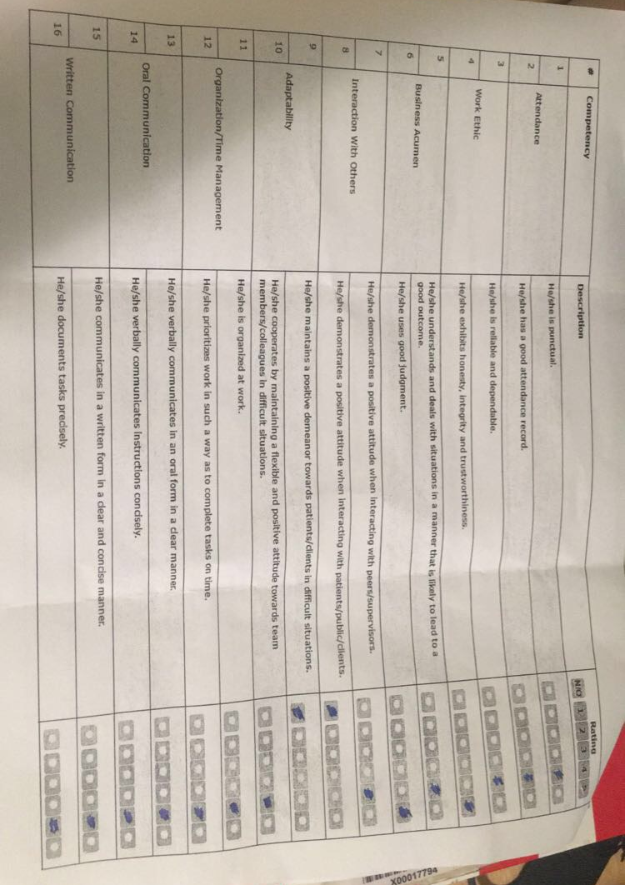
Career Field Experience has pushed my more in the direction of my original major: accounting. After working hand in hand with adults that have pursued my aspirations I am encouraged to acquire more experience in the field and learn more for what my future entails. This has been the most beneficial course I have ever taken at Lake Shore throughout my four years. I would highly recommend this experience to any person attending Lake Shore that is interested in learning more about what they would like to pursue in the future. I believe that this gave me an honest perception on what one of the sides of the business field is like and what is expected of you. This experience has been so rewarding due to the memories made throughout it.
A moment I will never fail to forget it not necessarily a positive experience. During the last few weeks of my internship, the general election took place. There are over 20 elected officials in my building, therefore a lot could be changed and was changed by one election. The day after the general election, November 9th, my boss’s expression was something I would never forget. Derek Miller, the current treasurer of Macomb County, lost the election by under 400 votes county wide. He was questioning where he went wrong campaigning or where the voters thought he was under-qualified; in reality, the main reason for the loss was under-educated voters. This exposed me to the significance of being educated on all types’ of elections, local and national. I plan on continuing this internship to gain more experience in this field. Additionally, in the future I would like to acquire an internship from a business like Quicken Loans or Google Inc,. This would present myself with contrasting experiences and opportunities, discovering the different aspects of business and accounting degrees.

